Filtering Efficiency of N95 Facepiece Respirators…… in Air Environments (Times New Roman, font 16, bold, centered, single line space. Leave one line space below)

Byung Uk Lee¹, Mikhail Yermakov², Sergey A. Grinshpun^{2*} (Times New Roman, font 14, bold, centralized; insert the foot note for the corresponding author; single line space. Leave one line space below)

¹Environment & Process Technology Division, Korea Institute of Science and Technology,
39-1 Hawolgok-dong, Seongbuk-gu, Seoul, Korea
²Center for Health-Related Aerosol Studies, Department of Environmental Health,
University of Cincinnati, 3223 Eden Avenue, PO Box 670056, Cincinnati, Ohio 45267-0056, USA (italicized, Times New Roman, font 12, single line space, leave one line space below)

∗ Corresponding author. Tel: 1-555-555-0504; Fax: 1-555-555-2263
E-mail address: xxx@yyy.edu

Abstract (Times New Roman, font 14, bold. Leave one line space below)

The emission of unipolar air ions in the vicinity of a filtering facepiece respirator has been recently shown to considerably enhance its respiratory protection efficiency. The effect is driven by the electric repelling forces that develop between the unipolarly charged mask and the aerosol particles, thus creating a shield for the incoming particles and consequently decreasing the penetration efficiency through the filter…………………(Submit the original word file on-line and the system will create the pdf/html file for the review purpose only. Before submitting the manuscript, check the pdf file created by the on-line system. Use A4 size paper, and set left margin = 2.2 cm, right margin = 2.2 cm, top margin = 3.0 cm, bottom margin = 3.0 cm. Times New Roman, font 12, single line space. Leave only “one space” after period. Not to exceed 300 words limit. Insert line numbers at the left margin of the entire manuscript using “page setup” function. The Word documents of manuscripts in new submissions must be clean. The 'tracked changes' tools should not be used or visible.).

Keywords: Respirator; Mask, Ion emission, Fine aerosol, Ultrafine aerosol. (3 to 5 keyword, Times New Roman, font 12, separated by commas, single line space.)
- INTRODUCTION (Introduction starts from 2nd page. SECTION LEVEL 1: Times New Roman, font 14, capitalized, left-justified, single line space for the section and subsection title, and double line space for the main text. Leave one line space below the section title)

The facepiece filtering respirators has been widely used to reduce human exposure to the aerosol particles. The respirator performance has been extensively studied…. (Hinds and Bellin, 1988; Brosseau et al., 1989). (Double line space for the text; one space after “period”. Times New Roman, font 12. This also shows the format of the references cited in the text. Each cited reference must appear in the REFERENCES section. The format of “Hinds and Bellin, 1988” is for two authors, while that of “Brosseau et al., 1989” is for more than two authors.). Based on the collaboration of NIOSH, the U.S. Army Soldier Biological and Chemical Command (SBCCOM), and the National Institute for Standards and Technology (NIST), appropriate standards….. (Always spell out the full name of an acronym at its first appearance).
Although the effort towards the performance evaluation and standardization of conventional disposable …………. (Leave no line space between paragraphs. At the beginning of and after the section name, hit “return”).

- METHODS

The experiments were conducted in an unventilated indoor test chamber (L × W × H = 3.78 m × 2.44 m × 2.64 m = 24.3 m³). Fig. 1 demonstrates the schematic diagram of the experimental setup. A breathing manikin with a face-sealed filtering mask was exposed to a polydisperse test aerosol. The leakage tests were conducted prior to the experiments with a detergent-based leakage-detecting liquid (Trubble Bubble, New Jersey Meter Co., Paterson, NJ, USA) to identify possible macro-leaks (> 1 µm) between the mask and the face of the manikin…………………

- RESULTS AND DISCUSSION (LEVEL 1)

  - Penetration Efficiency of Different Masks Affected by the Continuous Unipolar Air Ion Emission (LEVEL 2: Times New Roman, font 12, left-justified, title case heading. No line spaces after the sub-section title.)
Fig. 2(a) demonstrates the effect of continuous negative ion emission produced by a powerful VI-2500 ionic air purifier on the filtering efficiency of a face-sealed dust-mist respirator. The latter operated at 30 L min^{–1} (Express derived units or other units in exponent form with spaces between the elements of the derived unit, e.g., 100 µg m^{–3} and 20 µg m^{–2} day^{–1}.). Fig. 2(b) shows that the penetration efficiency………………..
Based on these parameters and assuming growth of particles at constant rate, the GR can be written (Kulmala, 1998) as (Always leave one line space before and after an equation by hitting “return”)

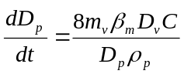 (1)

where m_{v} is the molecular mass of condensable vapor, C is the concentration of vapors responsible for the particle growth, and ρ_{p} is particle density. Eq. (1) can be integrated from D_{p0} to D_{p} to obtain………….
The data are presented in Table 1. All the facepiece filtering masks …………………....

    - Effect of the air ion polarity and emission rate (LEVEL 3: Times New Roman, font 12, left-justified, sentence case heading. No line spaces after the sub-section title.)
The continuous emission of unipolar ions at the same rate caused approximately the same enhancement effect, irrespective whether the emitted ions were positive [AS150MM (+)] or negative [AS150MM (-)]. The effect of the polarity of air ions is shown in Fig. 5 for the R95 respirator (a and b) and surgical mask (c and d) operated at 30 L min^{–1}…

- CONCLUSIONS

Continuous emission of unipolar air ions by corona-ionizing air purifiers in the vicinity of a disposable half-mask respirator enhanced its protection characteristics against fine and ultrafine particles of bacterial and viral size ranges. In this study, the effect ……………….

ACKNOWLEDGMENTS

The participation of Dr. Byung Uk Lee in this study was supported in parts by the Korea Science & Engineering Foundation (KOSEF). The authors wish to thank ………………..

DISCLAIMER

Reference to any companies or specific commercial products does not constitute …...

REFERENCES

Brosseau, L.M., Evans, J.L., Ellenbecker, M.J., Feldstein, M.L. (1989). Collection efficiency of respirator filters challenged with monodisperse latex aerosols. Am. Ind. Hyg. Assoc. J. 50, 544–549. https://doi.org/10.1080/15298668991375137 (References should be arranged in alphabetical order by the first author’s last name. The title of the cited journal should be abbreviated as in the Word List of Scientific Periodicals. For example, Aerosol and Air Quality Research should be abbreviated as Aerosol Air Qual. Res. Include the full title if the correct abbreviation is not known. AAQR provides EndNote output style and CSL style that supports the formatting of in-text citations and reference lists.)
Hinds, W.C., Bellin, P. (1988). Effect of facial-seal leaks on protection provided by half-mask respirator. Appl. Ind. Hyg. 3, 158–164. https://doi.org/10.1080/08828032.1988.10388550
Charell, P.R., Hawley, R.E. (1981). Characteristics of water adsorption on air sampling filters. Am. Ind. Hyg. Assoc. J. 42, 353–360. https://doi.org/10.1080/15298668191419875
Kerker, M. (1969). The scattering of light, 1st ed. Academic Press, New York.
Crittenden, B.D., Long, R. (1976). The mechanisms of formation of polynuclear aromatic compounds in combustion systems, in: Freudenthal, R.I., Jones, P.W. (Eds.), Carcinogenesis—A comprehensive survey, Vol. 1, Raven Press, New York, pp. 209–231.
(Tables and figures can be placed either in the main text, or on separate pages at the end with tables, followed by figures. In the latter case, place each table and figure on a separate page of the Word document. Authors do NOT need to prepare table titles and figure captions separately from the tables and figures. Instead, keep the titles and captions alongside with the tables and figures, respectively.)

Table 1. Descriptive statistics of the MTBE and BTEX measured at four night markets and a background location during night market activity periods.
Concentration (µg m^{–3}) | Mean | Median | S.D. | Min. | Max.
MTBE
Liu-Ho | 45.74 | 47.18 | 20.63 | 22.13 | 78.83
Rui-Guang | 155.92 | 136.89 | 76.48 | 51.72 | 247.70
Ping-Tung | 146.86 | 96.31 | 113.38 | 13.28 | 303.45
Chao-Zhou | 105.70 | 97.18 | 46.33 | 42.21 | 171.70
NPUST campus | 12.20 | 11.57 | 13.08 | ND | 31.09
Benzene
Liu-Ho | 7.89 | 8.92 | 2.91 | 4.04 | 11.92
Rui-Guang | 26.20 | 22.71 | 12.63 | 8.93 | 43.12
Ping-Tung | 25.79 | 15.84 | 20.56 | ND | 54.18
Chao-Zhou | 21.47 | 19.45 | 11.12 | 7.47 | 36.91
NPUST campus | 1.57 | 0.00 | 4.16 | ND | 11.01
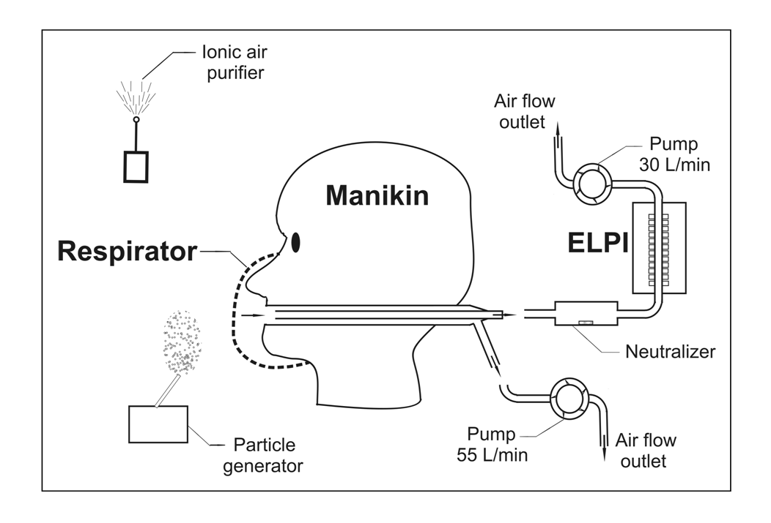
Fig. 1. Experimental setup.

(Place each table and figure on a separate page of the Word document.)

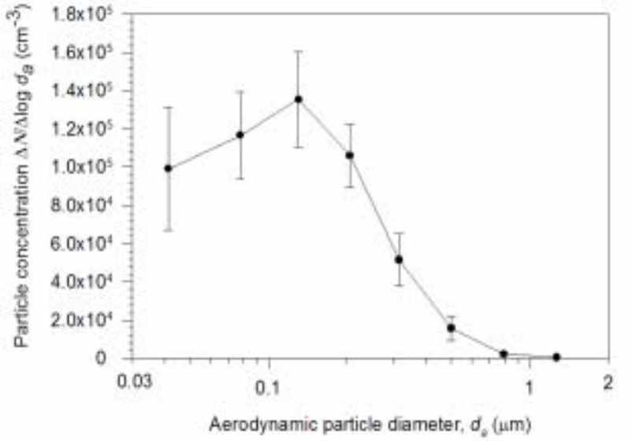
Fig. 2. Penetration efficiencies of the dust-mist (a) and N95 (b) respirators operating at 30 L min^{–1}. Continuous air ion emission is produced by VI-2500.

All submitting authors are advised to visit AAQR’s Online Submission webpage (https://aaqr.org/page/online-submission) for the latest Instructions for Authors, Open Access License Agreement, Publication Fees and the ongoing Call for Papers.

For more detailed information about manuscript preparation, please refer to the online version of Instructions for Authors at https://aaqr.org/page/instructions-for-authors.

